**Blockchain chat dapp**

**Abstract**

Blockchain technology has revolutionized various industries by introducing decentralized and secure solutions. In this project, we propose the development of a decentralized chat application (DApp) leveraging React.js and blockchain technology. The primary objective of this application is to provide users with a secure, private, and censorship-resistant platform for communication.

The proposed DApp utilizes the Ethereum blockchain for its decentralized architecture, ensuring data immutability and integrity. Smart contracts are employed to manage user authentication, message encryption, and storage. React.js is chosen for the frontend development due to its flexibility, scalability, and ease of use.

Key features of the DApp include end-to-end encryption for messages, user anonymity, and decentralization of data storage. Users can create accounts, send encrypted messages to other users, and join public or private chat rooms. The chat history is stored on the blockchain, ensuring tamper-proof records and guaranteeing the privacy of communications.

The development process involves designing and implementing smart contracts for user authentication and message encryption, integrating blockchain functionality into the React.js frontend, and testing the application for security vulnerabilities and usability.

The outcome of this project will be a fully functional decentralized chat application that demonstrates the potential of blockchain technology in ensuring secure and private communication. By leveraging React.js for the frontend development, the application will offer a seamless user experience while harnessing the benefits of blockchain technology for data integrity and decentralization.

**CHAPTER 1**

**Introduction**

In the digital age, communication is paramount, yet traditional messaging platforms often face challenges related to privacy, security, and centralized control. Blockchain technology offers a compelling solution to address these issues by providing a decentralized and tamper-proof platform for communication. In this context, the development of a decentralized chat application (DApp) using React.js presents an innovative approach to creating a secure and censorship-resistant messaging platform.

The objective of this project is to harness the power of blockchain technology to build a DApp that prioritizes user privacy and security. By leveraging the Ethereum blockchain and smart contracts, we aim to create a messaging platform where users can communicate freely without concerns about data breaches, surveillance, or interference from third parties.

This introduction sets the stage for exploring the motivation behind building a blockchain-based chat application and outlines the key goals and features of the proposed DApp. Additionally, it provides an overview of the technologies and methodologies that will be utilized throughout the development process, including React.js for the frontend and smart contracts for backend logic on the Ethereum blockchain.

Through this project, we seek to demonstrate the potential of blockchain technology to revolutionize communication by offering a decentralized alternative to traditional messaging platforms. By combining the transparency and security of blockchain with the user-friendly interface of React.js, we aim to deliver a robust and user-centric solution that empowers individuals to communicate securely in the digital realm.

**Module Description**

In this module, participants will learn how to integrate blockchain functionality into their React.js frontend. This involves connecting the frontend to the Ethereum blockchain using web3.js, a JavaScript library that allows interaction with Ethereum nodes. Participants will understand the process of setting up a connection to the blockchain network, including specifying the provider and configuring web3.js to communicate with smart contracts deployed on Ethereum. Through hands-on exercises and tutorials, participants will gain practical experience in interacting with smart contracts from their React.js components, such as calling contract functions, reading contract state, and listening for events. By the end of this module, participants will be equipped with the knowledge and skills to seamlessly incorporate blockchain features into their React.js applications, enabling decentralized and secure communication functionalities in the blockchain chat DApp.

**Introduction to Blockchain Technology:**

This module provides an overview of blockchain technology, including its principles, components, and applications. Topics covered may include distributed ledger technology, consensus mechanisms, and smart contracts. Participants will gain a foundational understanding of how blockchain works and its potential benefits for decentralized applications.

**React.js Fundamentals:**

This module introduces React.js, a popular JavaScript library for building user interfaces. Participants will learn the basics of React.js, including components, state management, and JSX syntax. Hands-on exercises and tutorials will allow participants to practice building simple React components and understand how they can be used to create dynamic and interactive user interfaces.

**Setting Up the Development Environment:**

In this module, participants will learn how to set up their development environment for building a blockchain chat DApp using React.js. This includes installing necessary tools and dependencies such as Node.js, Truffle, and Ganache for local blockchain development. Participants will also learn how to initialize a new React.js project and configure it for blockchain integration.

**Creating Smart Contracts:**

This module focuses on smart contract development using Solidity, the programming language for Ethereum smart contracts. Participants will learn how to write smart contracts for user authentication, message encryption, and storage. Topics covered may include contract structure, functions, events, and modifiers. Participants will also learn how to compile and deploy smart contracts using tools like Truffle.

**Integrating Blockchain with React.js:**

In this module, participants will learn how to integrate blockchain functionality into their React.js frontend. This includes connecting the frontend to the Ethereum blockchain using web3.js, interacting with smart contracts, and handling asynchronous calls. Participants will learn how to display blockchain data in their React components and enable users to interact with the blockchain through the DApp interface.

**Implementing User Authentication and Encryption:**

This module focuses on implementing user authentication and message encryption features in the DApp. Participants will learn how to authenticate users using Ethereum accounts and private keys, and encrypt messages using cryptographic algorithms such as AES. Topics covered may include key management, encryption algorithms, and secure messaging protocols.

**Testing and Deployment:**

In this module, participants will learn how to test and deploy their blockchain chat DApp. Participants will learn how to write and execute unit tests for smart contracts using tools like Truffle Test, and how to deploy their DApp to a test network such as Ropsten or Rinkeby. Participants will also learn best practices for deploying DApps to the Ethereum mainnet, including gas optimization and contract verification.

**Conclusion and Future Directions:**

This final module summarizes the key concepts covered in the course and discusses potential future directions for further development and enhancement of the blockchain chat DApp. Participants will have the opportunity to reflect on their learning experience and explore opportunities for applying their newfound skills in real-world projects or further research.

Key Features:

**Decentralization:**

The chat application operates on a decentralized network, ensuring that there is no single point of failure and making it resistant to censorship or shutdown.

**End-to-End Encryption:**

Messages exchanged between users are encrypted using robust encryption algorithms, ensuring that only the intended recipients can decrypt and read the messages.

**User Authentication:**

Users can securely authenticate themselves using their Ethereum accounts or private keys, providing a seamless and secure login experience without the need for third-party authentication services.

**Public and Private Chat Rooms:**

Users have the flexibility to join public chat rooms for open discussions or create private chat rooms for more secure and confidential conversations.

**Immutable Message History:**

All chat messages are stored on the blockchain, ensuring transparency and immutability of the conversation history. This prevents tampering or deletion of messages by any party.

**User Anonymity:**

Users have the option to maintain their anonymity while using the chat application, as Ethereum accounts are pseudonymous by nature. This protects user privacy and enhances security.

**Real-Time Messaging:**

The application supports real-time messaging, allowing users to engage in instant communication with minimal latency.

**Cross-Platform Compatibility:**

The chat application is accessible across multiple platforms, including web browsers and mobile devices, providing users with flexibility and convenience in accessing the service.

**Smart Contract Integration:**

Smart contracts handle critical functionalities such as user authentication, message encryption, and storage, ensuring the integrity and security of the chat application's operations.

**Scalability:**

The architecture of the chat application is designed to scale efficiently, accommodating a growing user base without compromising performance or security.

These key features collectively contribute to the development of a robust and user-centric decentralized chat application that prioritizes security, privacy, and usability.

**Methodology**

The development methodology for creating a blockchain chat DApp using React involves a systematic approach to ensure the successful implementation of key features and functionalities. Initially, thorough requirement gathering and analysis are conducted to understand project objectives and user needs. Following this, appropriate technologies are selected, with React.js chosen for frontend development due to its flexibility and Ethereum blockchain for its decentralized architecture. The application architecture is meticulously designed to facilitate seamless interaction between frontend components and smart contracts, emphasizing scalability, security, and user experience. Subsequently, frontend development commences, focusing on creating intuitive user interfaces for registration, authentication, and messaging functionalities. Concurrently, smart contracts are developed in Solidity to manage user authentication, message encryption, and storage on the blockchain. Integration with the blockchain is achieved using Web3.js, enabling communication with deployed smart contracts. Rigorous testing and debugging are undertaken to identify and rectify any issues, ensuring the reliability and functionality of the DApp. Security auditing is conducted to mitigate potential vulnerabilities, followed by deployment to test and mainnet environments. Finally, user education and support mechanisms are established to assist users in navigating the DApp and addressing any queries or concerns they may encounter. Through this methodology, developers can deliver a robust and user-centric blockchain chat DApp, offering users a decentralized and secure platform for communication.

Methodology for Developing a Blockchain Chat DApp using React:

**Requirement Gathering and Analysis:**

This initial phase involves understanding the project's objectives, target audience, and functional requirements. It includes identifying key features such as user authentication, message encryption, and decentralized storage. Stakeholder feedback and input are crucial during this phase to ensure alignment with expectations.

**Technology Selection and Setup:**

In this phase, the appropriate technologies are chosen based on project requirements. React.js is selected for frontend development due to its flexibility and component-based architecture. Ethereum blockchain is chosen for its decentralized nature and smart contract capabilities. Development environments like Truffle and Ganache are set up to facilitate local blockchain development.

**Designing the Application Architecture:**

The architecture of the chat DApp is designed, outlining the interaction between frontend components, smart contracts, and the Ethereum blockchain. Decisions regarding data flow, component hierarchy, and state management are made during this phase. The design should prioritize scalability, security, and user experience.

**Frontend Development with React.js:**

The frontend development process begins with creating user interface components using React.js. This includes designing screens for user registration, login, chat rooms, messaging interfaces, and settings. React Router may be used for managing navigation between different screens. UI/UX design principles are applied to ensure an intuitive and visually appealing interface.

**Smart Contract Development:**

Smart contracts are developed using Solidity, Ethereum's programming language for writing smart contracts. Contracts are created to manage user authentication, message encryption, and storage on the blockchain. Consideration is given to gas optimization and contract efficiency to minimize transaction costs.

**Integration with Blockchain:**

Web3.js, a JavaScript library for interacting with Ethereum nodes, is used to connect the React.js frontend with the Ethereum blockchain. This allows communication with smart contracts deployed on the blockchain, enabling functionalities such as user authentication and message storage. Integration is tested thoroughly to ensure seamless interaction between frontend and blockchain components.

**Testing and Debugging:**

The chat DApp undergoes extensive testing to identify and fix bugs, ensure functionality, and validate user interactions. Unit tests are written for smart contracts to verify their behavior under different conditions. Automated testing frameworks may be used to streamline the testing process and improve code quality.

**Security Auditing and Optimization:**

Security audits are conducted to identify potential vulnerabilities in the smart contracts and frontend code. Best practices for secure coding, such as input validation and protection against reentrancy attacks, are followed. Gas optimization techniques are employed to minimize transaction costs and improve the efficiency of smart contracts.

**Deployment and Maintenance:**

Once testing and auditing are complete, the chat DApp is deployed to a test network (e.g., Ropsten or Rinkeby) for final validation. After successful testing, the DApp is deployed to the Ethereum mainnet, making it accessible to users. Regular maintenance and updates are performed to address any issues and incorporate new features or enhancements based on user feedback.

**User Education and Support:**

User documentation and guides are provided to help users navigate the chat DApp and understand its features. Customer support channels are established to address user inquiries, troubleshoot issues, and gather feedback for continuous improvement.

By following this methodology, developers can effectively design, develop, and deploy a secure and user-friendly blockchain chat DApp using React.js, offering users a decentralized and censorship-resistant platform for communication.

**CHAPTER 2**

**SYSTEM DESCRIPTION**

### Software Requirements

|  |  |  |
| --- | --- | --- |
| Operating System | : | Windows 10& above |
| Simulator Tool | : | VS 17.7.6 |
| Back end  **Hardware Requirements** | : | REACT |
| Processor | : | Intel core i3(min) |
| RAM | : | Minimum 4 GB and Recommended 8 GB |
| Hard Disk | : | 24 GB to accommodate the project files, datasets, and software tools |
| Input Device | : | Standard Keyboard and Mouse |
| Output Device | : | Standard Monitor |

**System Tools**

Visual Studio Code is a fast and efficient source code editor available for Windows, Mac OS X, and Linux on your PC. Together with a strong ecosystem of extensions for additional languages and runtimes (such as C++, C#, Java, Python, PHP, Go, and.NET), it comes with built-in support for JavaScript, TypeScript, and Node.js. Using the Electron Framework, Microsoft created the source code editor Visual Studio Code, or VS Code, for Windows, Linux, and macOS. Embedded Git, snippets, intelligent code completion, debugging support, and syntax highlighting are a few of the features.

**Implementation**

**Setting Up the Development Environment:**

* Install Node.js and npm (Node Package Manager) to manage dependencies.
* Use Truffle Suite to initialize a new project for smart contract development.
* Create a new React.js project using create-react-app or a similar tool.
* Configure the React.js project to work with Truffle by setting up appropriate

directories and scripts.

**Smart Contract Development:**

* Write Solidity smart contracts to handle user authentication, message encryption, and storage.
* Define data structures and functions for user registration, login, message encryption, and storage.
* Test smart contracts locally using Truffle's development environment and ganache-cli for local blockchain testing.
* Write comprehensive unit tests for smart contracts using Truffle's testing framework.

**Frontend Development with React.js:**

* Design user interface components using React.js, such as login/signup forms, chat rooms, and message input fields.
* Organize components into a logical hierarchy and manage state using React's useState and useEffect hooks.
* Implement React Router to handle navigation between different screens, such as login, chat room, and settings screens.
* Utilize CSS frameworks like Bootstrap or Material-UI for styling and responsiveness.

**Integrating with Blockchain:**

* Install Web3.js library to connect the React frontend with the Ethereum blockchain.
* Initialize a Web3 instance and connect to an Ethereum node, either locally or through a remote provider like Infura.
* Use Truffle migrations to deploy smart contracts to the Ethereum blockchain.
* Configure the React frontend to interact with deployed smart contracts using their ABI (Application Binary Interface).

**User Authentication:**

* Implement user registration and login functionalities using Ethereum accounts or MetaMask wallet integration.
* Allow users to securely authenticate themselves by signing transactions with their private keys.
* Use smart contracts to manage user authentication and authorization, verifying user identities on the blockchain.

**Message Encryption and Decryption:**

* Implement message encryption and decryption functionalities using cryptographic algorithms like AES (Advanced Encryption Standard).
* Encrypt outgoing messages using the recipient's public key and decrypt incoming messages using the recipient's private key.
* Ensure that messages are securely transmitted over the blockchain network and cannot be intercepted or tampered with.

**Real-Time Messaging:**

* Integrate real-time messaging capabilities using libraries like Socket.io or web3-react.
* Implement event listeners to detect new messages and updates from other users in real-time.
* Update the UI dynamically to reflect new messages and chat room activity without requiring manual refresh.

**Testing and Debugging**:

* Test the application thoroughly to identify and fix any bugs or issues.
* Write unit tests for smart contracts and frontend components using testing frameworks like Mocha and Chai.
* Use debugging tools like Truffle Debugger and React Developer Tools to debug smart contracts and frontend code.

**Security Auditing and Optimization:**

* Conduct security audits to identify potential vulnerabilities in the smart contracts and frontend code.
* Implement best practices for secure coding, such as input validation, access control, and protection against reentrancy attacks.
* Optimize gas usage and efficiency of smart contracts to minimize transaction costs and improve scalability.

**Deployment:**

* Deploy the blockchain chat DApp to a test network (e.g., Ropsten or Rinkeby) for final validation.
* Once testing is successful, deploy the DApp to the Ethereum mainnet, making it accessible to users.
* Use deployment tools like Truffle Deploy or Remix to deploy smart contracts and frontend assets to the blockchain network.

**Documentation and Support:**

* Provide comprehensive documentation and user guides to help users navigate the DApp and understand its features.
* Create tutorials and walkthroughs to demonstrate how to use the DApp for new users.
* Establish customer support channels, such as email or chat support, to assist users with any queries or issues they may encounter.

By following these detailed implementation steps, developers can create a robust and user-friendly blockchain chat DApp using React, offering users a secure and decentralized platform for communication.

**CHAPTER 3**

**SYSTEM ANALYSIS**

**Existing system**

The existing system for chat applications predominantly relies on centralized architectures, where communication between users is facilitated through servers operated by service providers. These servers store user data, manage authentication processes, and handle the transmission of messages. However, this centralized model presents inherent vulnerabilities and limitations. Firstly, it raises concerns regarding privacy and security, as user data is stored on centralized servers, making it susceptible to potential breaches and unauthorized access. Moreover, the reliance on a single point of control makes the system vulnerable to censorship and manipulation by third parties. Additionally, the scalability of centralized systems can be a challenge, particularly during periods of high user activity, leading to performance issues and degraded user experience. Overall, while centralized chat applications offer convenience and ease of use, they often compromise on privacy, security, and resilience.

The centralized nature of existing chat applications also raises concerns about data ownership and control. Users must entrust their personal information and communication data to service providers, relinquishing control over how their data is stored, accessed, and utilized. This lack of control can lead to issues such as data mining, targeted advertising, and unauthorized surveillance, eroding user trust and privacy.

Furthermore, centralized chat applications are susceptible to single points of failure and downtime. If the centralized servers experience technical issues or are subjected to cyberattacks, it can result in service disruptions and the loss of communication capabilities for users. This lack of resilience can be particularly problematic during critical situations or emergencies when reliable communication is essential.

In addition, the centralized model limits innovation and interoperability within the chat ecosystem. Users are confined to proprietary platforms operated by specific service providers, hindering the development of alternative solutions and interoperable communication protocols. This lack of diversity can stifle competition and innovation, ultimately limiting user choice and flexibility in selecting communication tools that align with their preferences and values.

Overall, while centralized chat applications have dominated the market for years, their inherent limitations and vulnerabilities underscore the need for decentralized alternatives that prioritize user privacy, security, resilience, and innovation. By leveraging blockchain technology and decentralized architectures, developers can create chat applications that empower users with greater control over their data, enhanced security, and improved resilience to censorship and manipulation.

**Disadvantages of Existing system**

The existing system of centralized chat applications is associated with several disadvantages:

**Privacy Risks:**

Centralized chat applications store user data, including messages, contact lists, and profile information, on centralized servers. This centralized data storage increases the risk of privacy breaches, as user data is vulnerable to hacking, unauthorized access, and exploitation by malicious actors.

**Security Vulnerabilities:**

Centralized servers are susceptible to security vulnerabilities and cyberattacks, such as distributed denial-of-service (DDoS) attacks, data breaches, and malware infections. A successful attack on the centralized infrastructure can compromise the confidentiality, integrity, and availability of user data and communication channels.

**Data Ownership Concerns:**

In centralized chat applications, users relinquish control over their data to service providers. This lack of data ownership means that users have limited control over how their data is collected, stored, and utilized by the service provider, leading to concerns about data privacy and autonomy.

**Censorship and Surveillance:**

Centralized chat applications are subject to censorship and surveillance by governments, corporations, and other centralized authorities. Governments may impose restrictions on communication channels, monitor user activities, and censor content deemed inappropriate or politically sensitive, undermining freedom of expression and privacy rights.

**Single Point of Failure:**

Centralized chat applications rely on a single point of failure—the centralized server infrastructure. If the centralized servers experience technical issues, downtime, or cyberattacks, it can disrupt communication services for all users, leading to service outages and loss of connectivity.

**Lack of Transparency:**

Centralized chat applications operate under opaque governance structures, where service providers have control over the platform's policies, algorithms, and content moderation practices. This lack of transparency can lead to arbitrary decision-making, inconsistent enforcement of community guidelines, and limited accountability to users.

**Limited Interoperability:**

Centralized chat applications are often proprietary platforms that lack interoperability with other messaging services. Users are confined to communicating within the closed ecosystem of the platform, limiting their ability to interact with users on different platforms and fostering vendor lock-in.

**Scalability Challenges:**

Centralized chat applications may face scalability challenges, especially during periods of high user activity or rapid user growth. Scaling the centralized infrastructure to accommodate increased user demand can be complex, costly, and resource-intensive, leading to performance issues and degraded user experience.

Overall, the disadvantages of the existing system highlight the need for alternative solutions that prioritize decentralization, privacy, security, transparency, and interoperability in chat applications.

**Proposed System**

The proposed system introduces a decentralized chat application (DApp) that fundamentally alters the paradigm of traditional centralized chat platforms. Operating on blockchain technology, this system offers users a secure, privacy-centric, and censorship-resistant environment for communication. Through decentralization, the reliance on centralized servers is eliminated, mitigating the vulnerabilities associated with single points of failure and reducing the risk of data breaches. Encryption mechanisms safeguard user messages end-to-end, ensuring that only the intended recipients can access the content, thus enhancing privacy and confidentiality. Moreover, user authentication is managed through decentralized identity systems, such as blockchain-based authentication methods, ensuring robust security measures and safeguarding user data from unauthorized access. By prioritizing user ownership and control over their data, the proposed system empowers users to manage their cryptographic identities and private keys, enabling them to assert greater autonomy over their communication data. Overall, the proposed system represents a significant shift towards decentralized, privacy-preserving communication platforms, offering users unprecedented levels of security, privacy, and control over their digital interactions.

**Advantages of Proposed system**

The advantages of the proposed decentralized chat application:

**Enhanced Privacy and Security:**

* End-to-End Encryption: Messages are encrypted before transmission and decrypted only by the intended recipients, ensuring that communication remains private and secure.
* Decentralized Authentication: Authentication processes are managed through decentralized identity systems, such as blockchain-based authentication methods or decentralized identifiers (DIDs), reducing the risk of unauthorized access and identity theft.
* Immutable Data Storage: Message history is stored on the blockchain, providing tamper-proof and immutable records, which enhances security and prevents data manipulation.

**Censorship Resistance:**

* Decentralized Architecture: The absence of a central authority or single point of control makes the system resistant to censorship and manipulation by governments, corporations, or other centralized entities.
* Peer-to-Peer Communication: Communication occurs directly between users, without intermediaries or centralized servers, ensuring that conversations remain private and uncensored.

**Data Ownership and Control:**

* User Sovereignty: Users retain ownership of their cryptographic identities and private keys, enabling them to control access to their data and assert greater autonomy over their digital interactions.
* Self-Sovereign Identity: Decentralized identity systems empower users with self-sovereign identity management, allowing them to manage their identity information independently and securely.

**Resilience to Single Points of Failure:**

* Redundancy and Distribution: Data is distributed across a network of nodes, reducing the risk of single points of failure and enhancing system resilience.
* Fault Tolerance: Even if individual nodes fail or become unavailable, the decentralized nature of the system ensures that communication can continue uninterrupted.

**Interoperability and Open Standards:**

* Open Protocols: The system adheres to open communication protocols and standards, enabling interoperability with other decentralized chat platforms and reducing vendor lock-in.
* Cross-Platform Compatibility: Users can communicate seamlessly across different platforms and devices, fostering inclusivity and accessibility.

**Transparency and Accountability:**

* Blockchain Transparency: The use of blockchain technology provides transparency and immutability, enabling users to audit and verify the integrity of communication data.
* Smart Contract Governance: Smart contracts governing authentication and encryption processes operate transparently on the blockchain, ensuring adherence to predefined rules and protocols.

**Community Governance:**

* Decentralized Decision-Making: Community-driven governance mechanisms empower users to participate in decision-making processes and shape the direction of the platform.
* Token-Based Governance: Governance tokens enable users to vote on proposals, allocate resources, and participate in the governance of the platform, fostering a sense of ownership and accountability.

**Scalability and Performance:**

* Scalable Blockchain Solutions: The use of scalable blockchain solutions and off-chain scaling techniques enhances system performance and accommodates growing user demand.
* Optimized Network Architecture: Network optimizations and protocol enhancements improve throughput and reduce latency, ensuring a smooth and responsive user experience even under high loads.

By incorporating these detailed advantages, the proposed decentralized chat application offers a comprehensive solution that addresses the limitations of traditional centralized platforms while prioritizing user privacy, security, data ownership, and community-driven governance.

**CHAPTER 4**

**SYSTEM DESIGN**

**Dapp Architecture**

**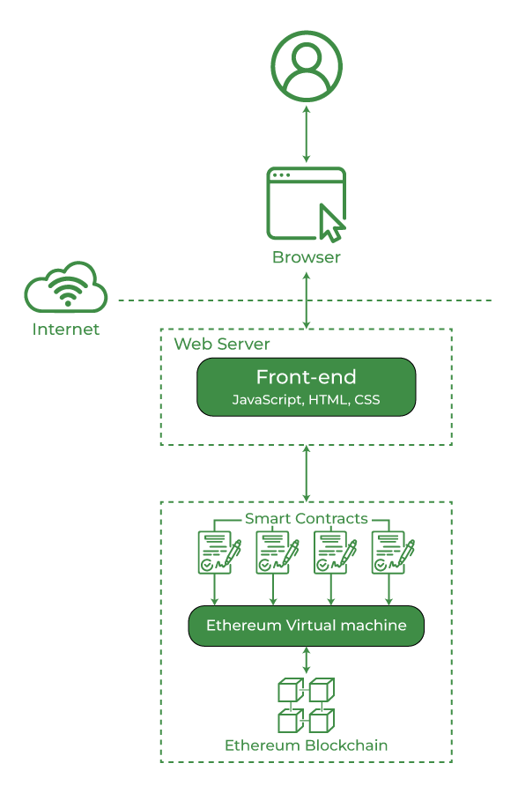**

# [Blockchain application in the form of a dApp](https://www.researchgate.net/figure/Blockchain-application-in-the-form-of-a-dApp_fig2_373399508" \t "_blank)

**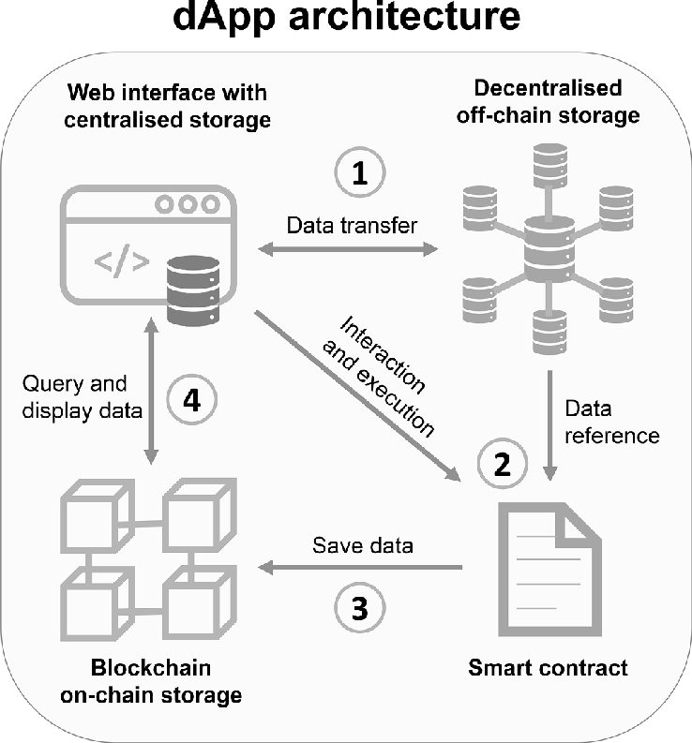**

**Input image**

**Screenshot**

**Output image**

**Screenshot**

**CHAPTER 5**

**Conclusion**

In conclusion, the proposed decentralized chat application represents a significant advancement in the realm of digital communication, offering a compelling alternative to traditional centralized chat platforms. By leveraging blockchain technology and decentralized architectures, the proposed system prioritizes user privacy, security, data ownership, and community-driven governance.

Through end-to-end encryption, decentralized authentication, and immutable data storage, the proposed system ensures that user communication remains private, secure, and resistant to censorship. Users retain ownership of their data and cryptographic identities, enabling them to assert greater control over their digital interactions and protect their privacy rights.

Moreover, the decentralized nature of the system enhances resilience to single points of failure, promotes interoperability and open standards, and fosters transparency, accountability, and community governance. By empowering users to participate in decision-making processes and shape the direction of the platform, the proposed system promotes inclusivity, autonomy, and user sovereignty.

Overall, the proposed decentralized chat application offers a comprehensive solution that addresses the shortcomings of centralized platforms while embracing the principles of decentralization, privacy, security, and community empowerment. By providing a secure, censorship-resistant, and user-centric platform for communication, the proposed system paves the way for a more decentralized and democratized digital future.

**Future Enhancement**

Future enhancements for the proposed decentralized chat application could include:

**File Sharing:**

Integrate file-sharing capabilities to allow users to exchange files securely within the chat application. Implement encryption mechanisms to ensure the privacy and security of shared files.

**Multi-Device Synchronization:**

Enable synchronization of chat history and settings across multiple devices, allowing users to seamlessly switch between devices without losing conversation continuity.

**Voice and Video Calling:**

Incorporate voice and video calling features to facilitate real-time communication between users. Implement end-to-end encryption for secure voice and video calls, ensuring privacy and confidentiality.

**Advanced Notification Settings:**

Enhance notification settings to allow users to customize their notification preferences for different chat rooms and conversation threads. Provide options for silent notifications, message previews, and notification scheduling.

**Integration with Decentralized Storage:**

Integrate with decentralized storage platforms, such as IPFS (InterPlanetary File System) or Swarm, to store message attachments and media files securely. Utilize encryption techniques to protect user data stored on decentralized storage networks.

**Enhanced User Profiles:**

Improve user profiles to include additional information such as profile pictures, status updates, and user preferences. Implement privacy settings to allow users to control the visibility of their profile information to others.

**Localization and Internationalization:**

Support multiple languages and locales to cater to a diverse user base worldwide. Enable localization and internationalization features to provide a seamless user experience for users from different regions and language preferences.

**Community Moderation Tools:**

Implement community moderation tools to empower users to moderate chat rooms and enforce community guidelines. Provide features for reporting abusive behavior, flagging inappropriate content, and blocking users.

**Integration with Decentralized Finance (DeFi):**

Explore integration with decentralized finance protocols to enable peer-to-peer payments and tipping within the chat application. Implement secure payment channels and smart contracts for seamless financial transactions between users.

**Machine Learning and Natural Language Processing:**

Utilize machine learning and natural language processing techniques to enhance chat moderation, sentiment analysis, and content recommendation features. Implement intelligent algorithms to detect spam, filter inappropriate content, and provide personalized recommendations for users.

By incorporating these future enhancements, the proposed decentralized chat application can evolve into a feature-rich, user-friendly, and robust platform that meets the diverse communication needs of users while maintaining a focus on decentralization, privacy, and security.